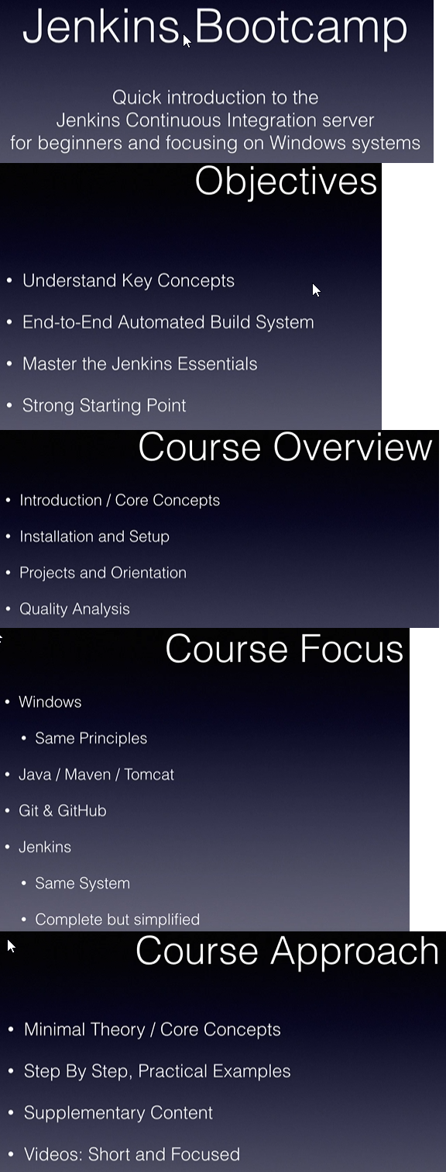

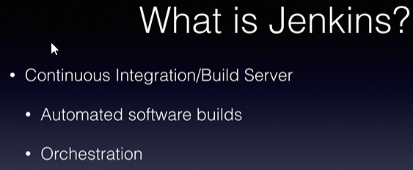

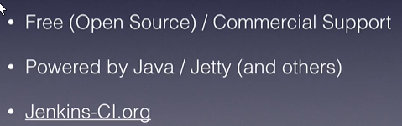

In the beginning projects are often built manually, which can be problematic and yield unreliable results.

Next step: Automate builds, using scripts or a build tool, using Ant or Maven.

Either way these build are still being run on developer systems, leading to ‘it runs on my box discussion’.

Next level up, the project dedicates a system exclusively for project builds, independent of any developer systems.

This system continuously monitors the project for changes, or on an ordained schedule, and then builds and distributes the project, but now with an independent build system in place.

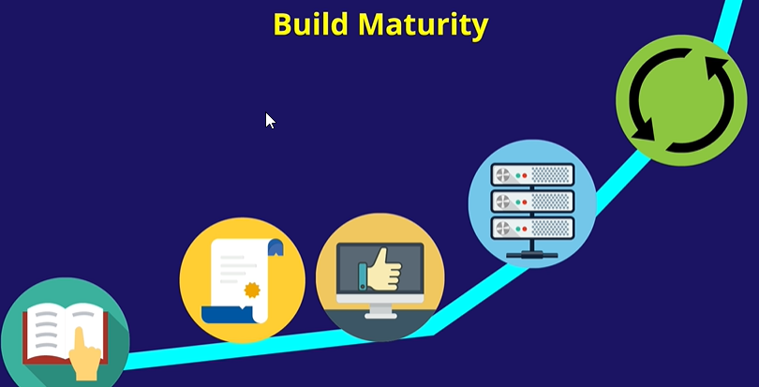

Next step is setting up the build system with increased amounts of automation and testing.

We start with continuous inspection and perhaps evolve to continuous deployment.

Continuous build cycle starts off with a build process, in our case Jenkins, Accessing the code from a source code repository and placing it on a dedicated build server anywhere but a developer’s computer system.

The build process then builds or compiles the project based on the retraced source code.

It also may perform static code analysis for review.

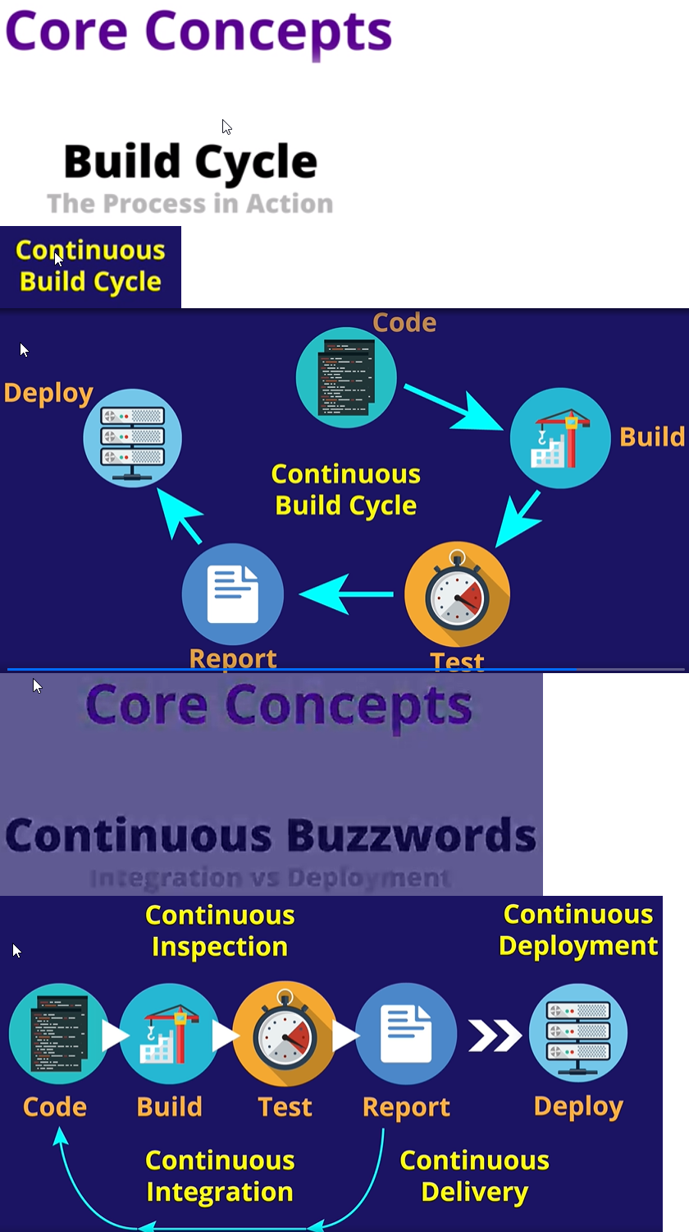

Jenkins runs on top of a java web application container or application server, by default this is Jetty.

Jenkins installer provides a packaged version of Jetty on which it would run.

Service: Starts, stops and monitors Jetty and Jenkins applications.

View: Way to group projects and views together.

Project: Provides configurations/ instructions on how to build software.

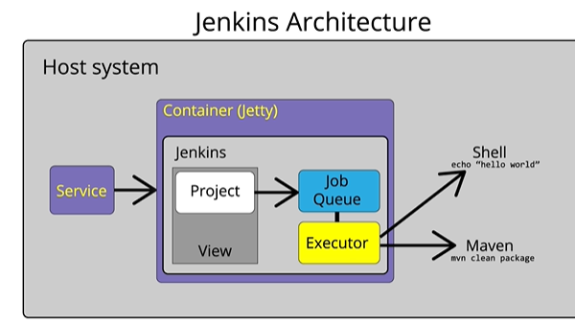Projects would queue up until there is an executor ready to execute the project build.

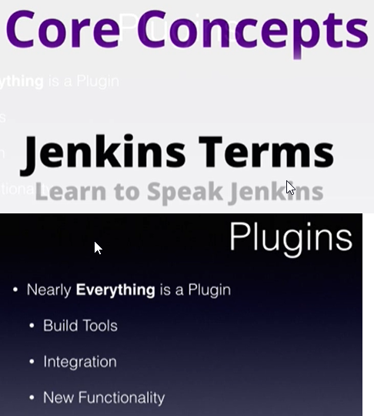

With Jenkins nearly everything is a plugin, and nearly all functionalities are provided by plugins.

Plugins: Small libraries that add new functionalities to Jenkins and can provide integration points to other tools.

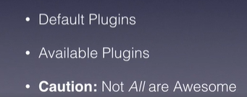

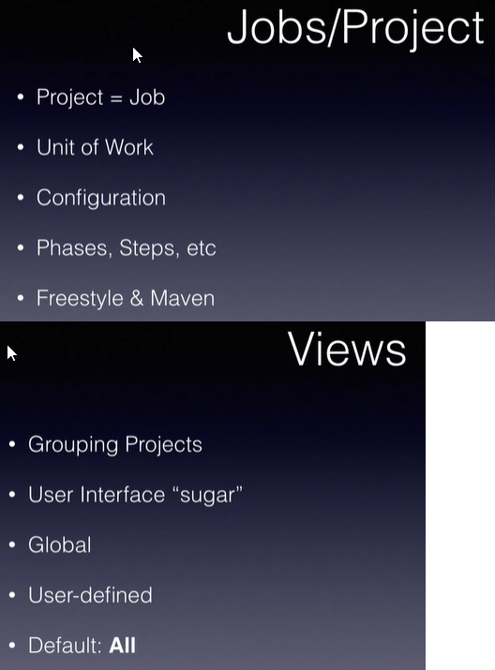Projects = Job, main unit of work in Jenkins.

The default view ‘All’ contains all the projects the user has access to.

Workspace: Place where Jenkins places all the requests regarding the Jenkins project and the related software project.

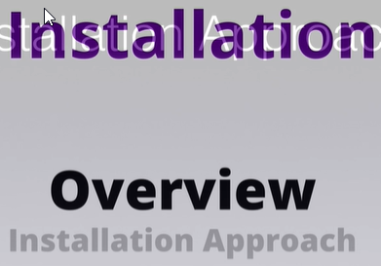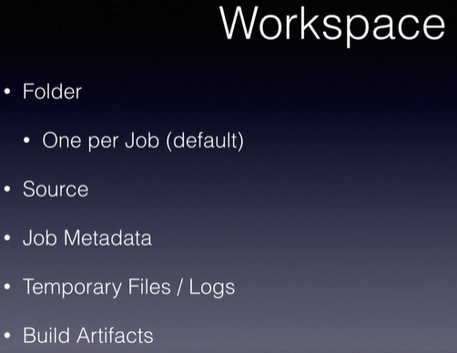

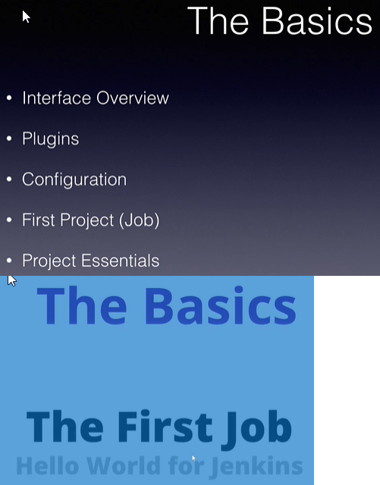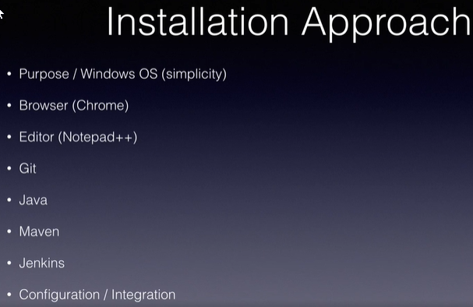

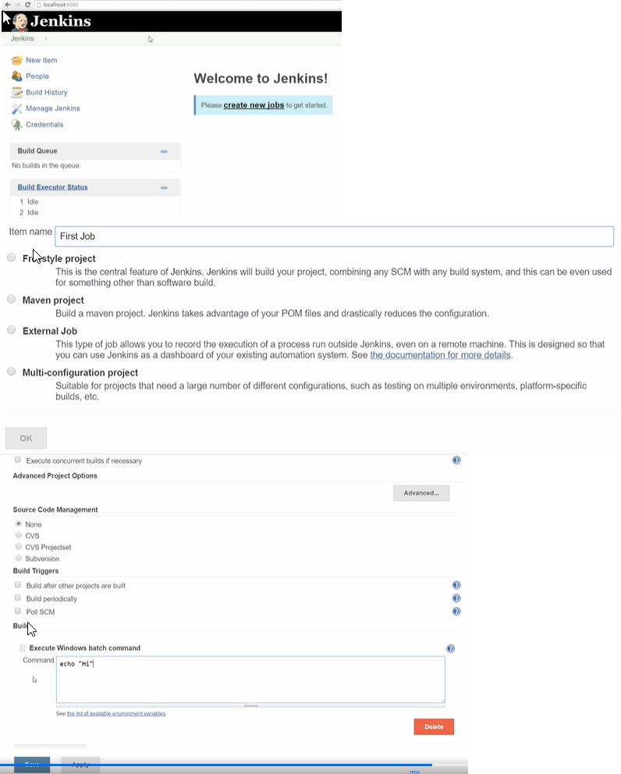

Freestyle project is selected. In build we type the command, echo “Hi”.

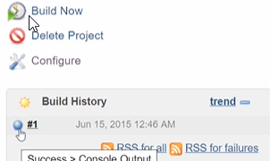

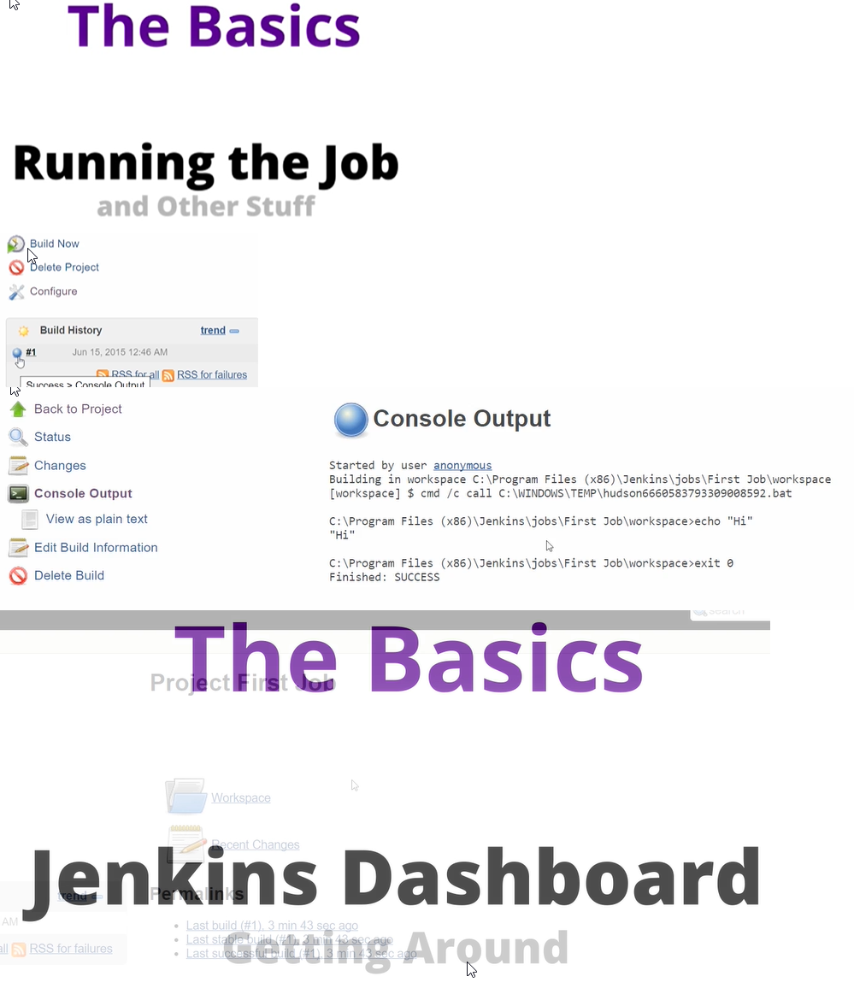We click ‘Build Now’.

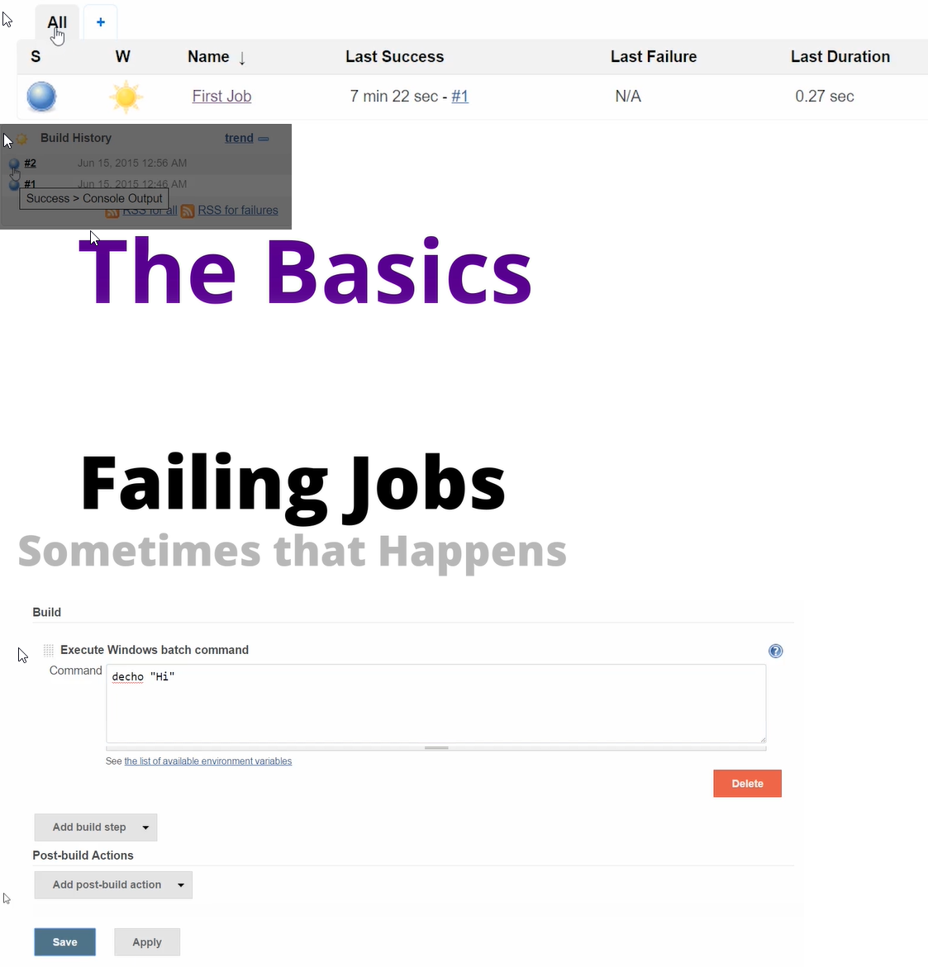

In configure tab, modify the command to something which does not exist.

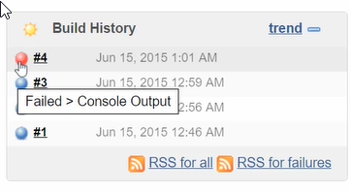

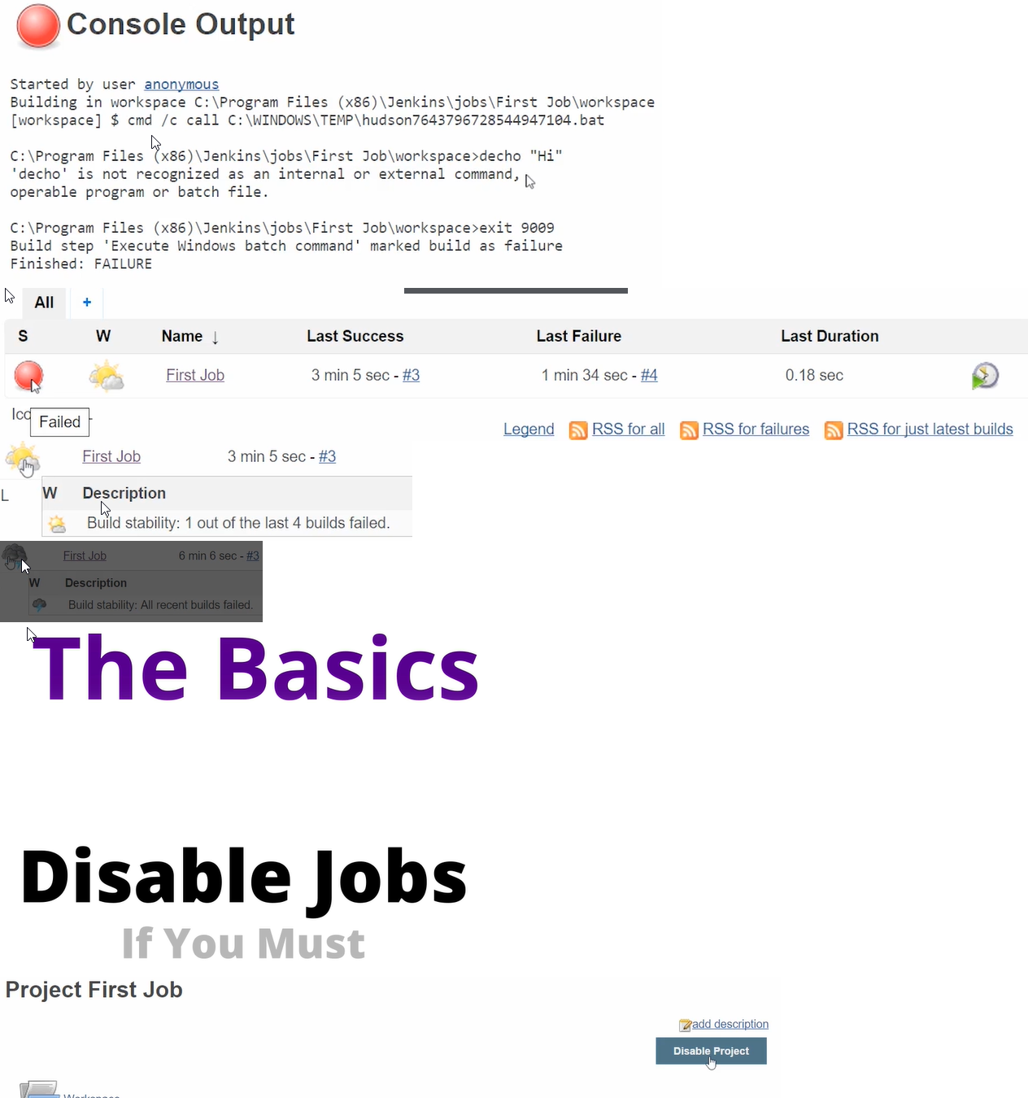We see build number 4 was not successful.

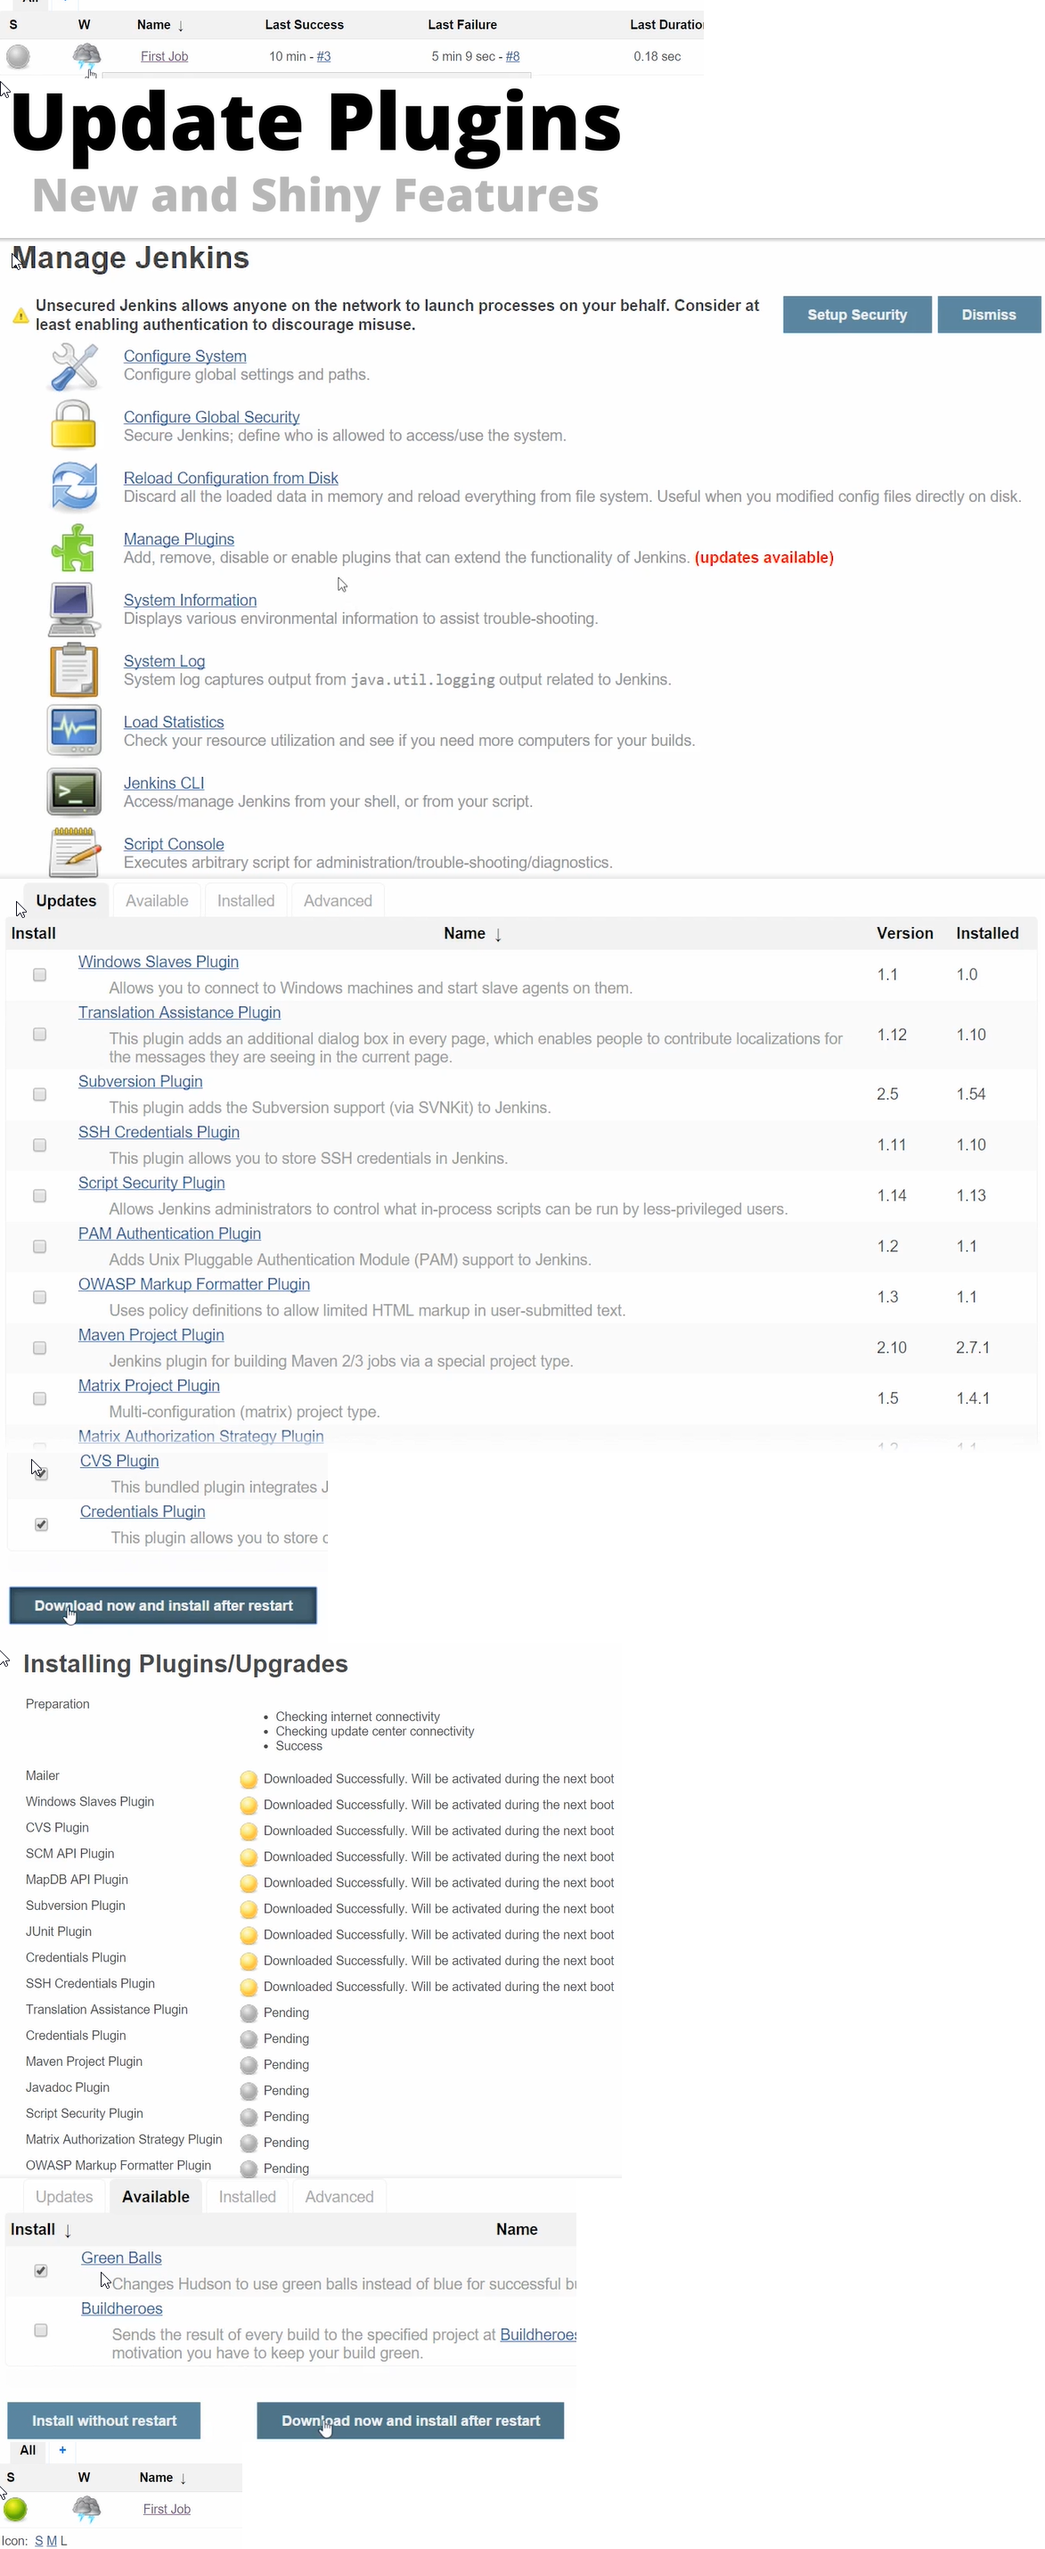

We edit the error and build again. We can delete individual jobs/builds provided we have necessary permissions.

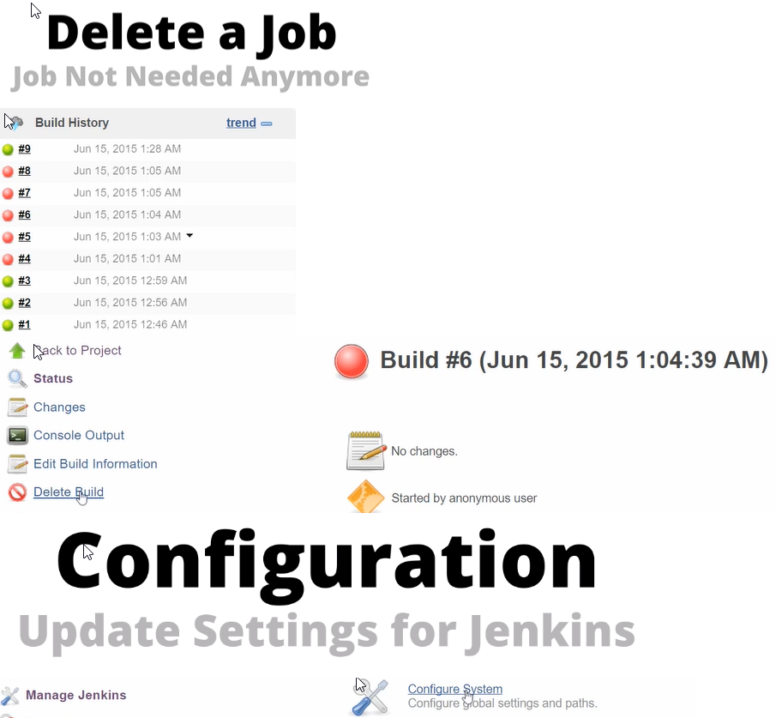

Give Maven home and JDK home paths.

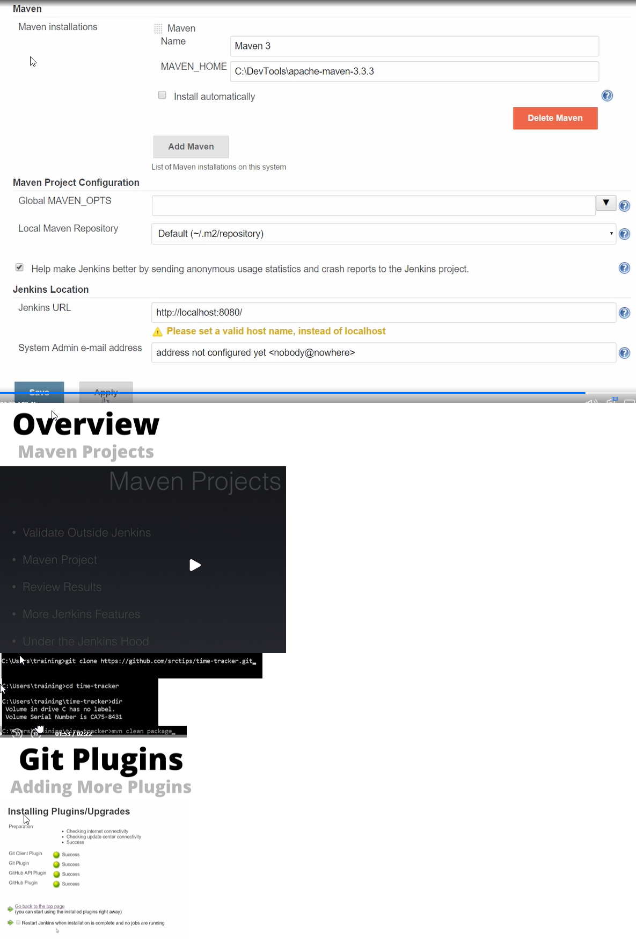

Jenkins automatically finds any dependency plugins.

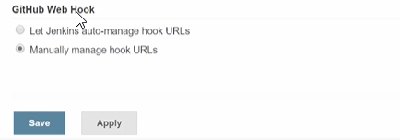

In configure we see the Github web hook option which confirms that the Github plugin has been installed.

Now after installing our dependencies we create our first maven based java build.

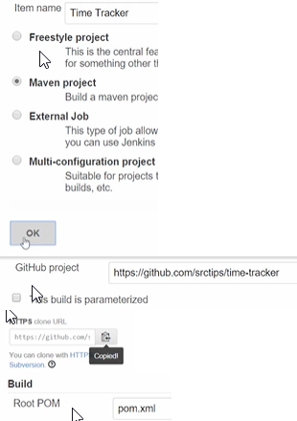Copy the HTTPS clone option in GIT and paste it in our Repository URL in Configure tab in Jenkins.

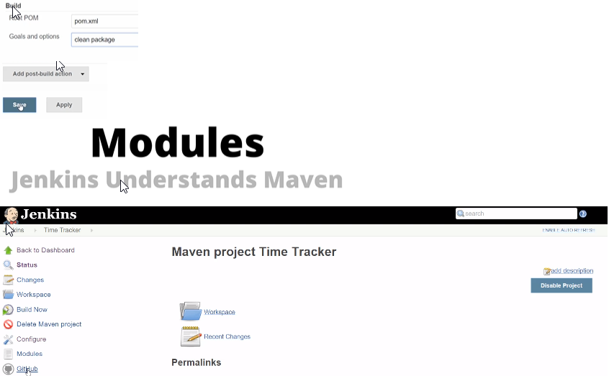

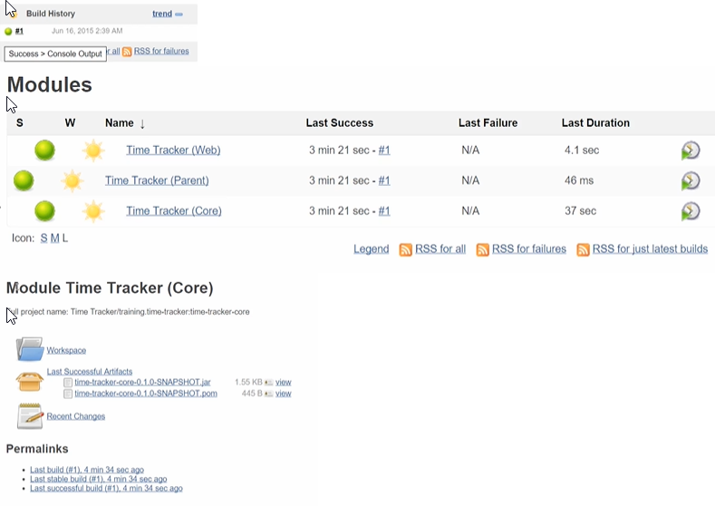Since we linked Jenkins to Github we have a Github option in our project.

We see 3 maven modules and associated workspace.

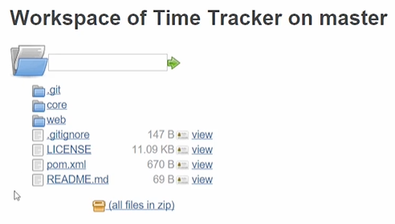

Click on workspace and Jenkins will show us the folder structure for our project.

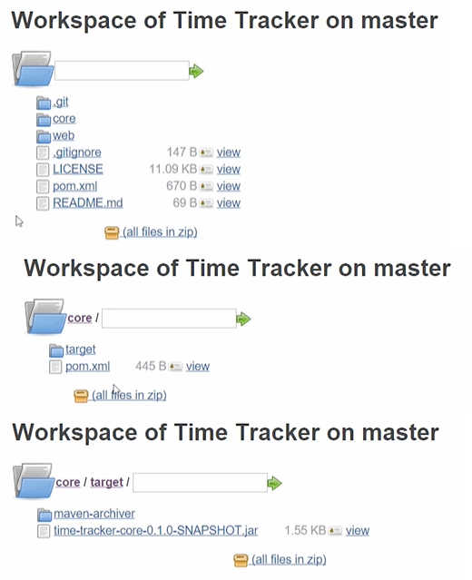

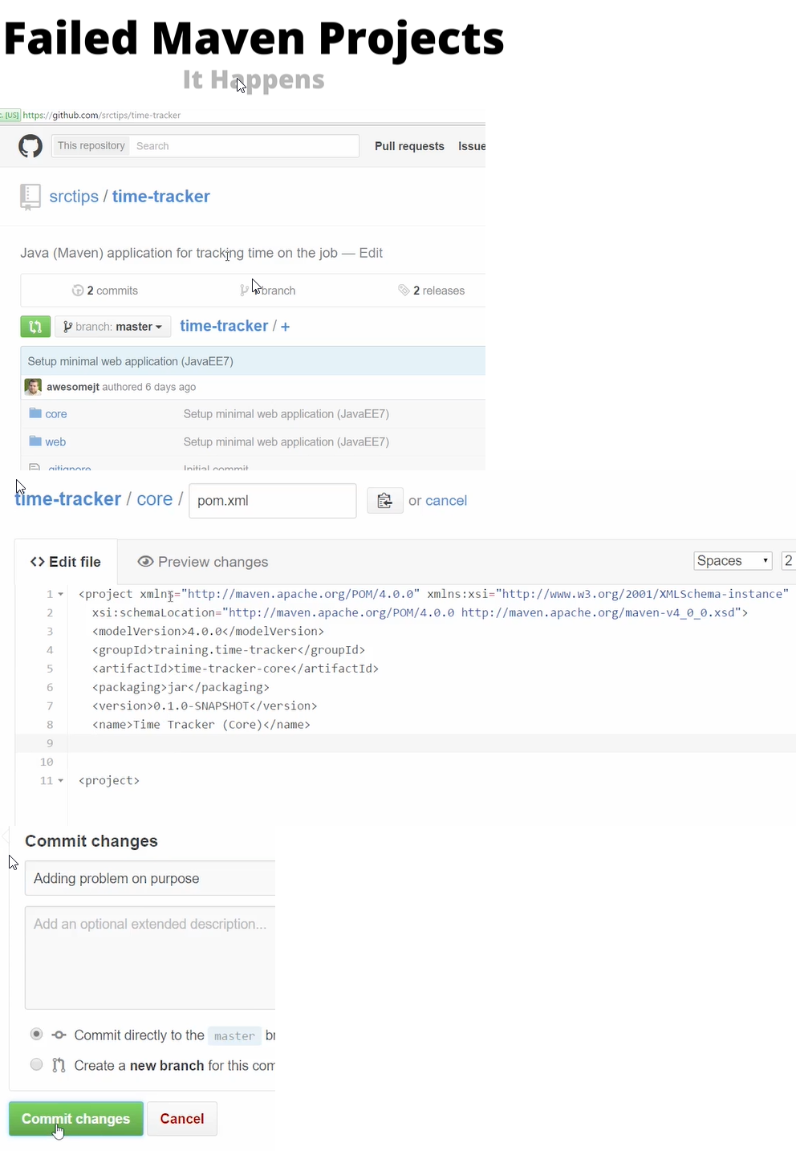In target directory we see the artifact that may be generated as part of the build process.

Adding a problem on pom.xml on purpose.

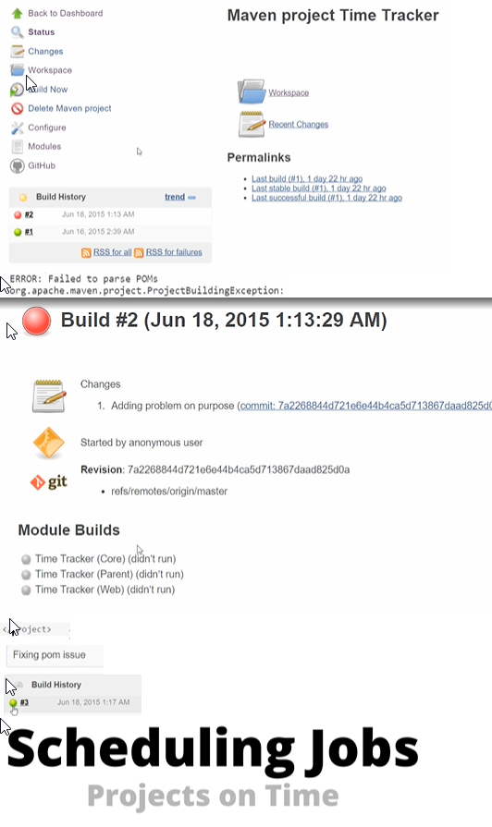

Here, we cover how to automate builds by scheduling them.

Configure-> Build Triggers

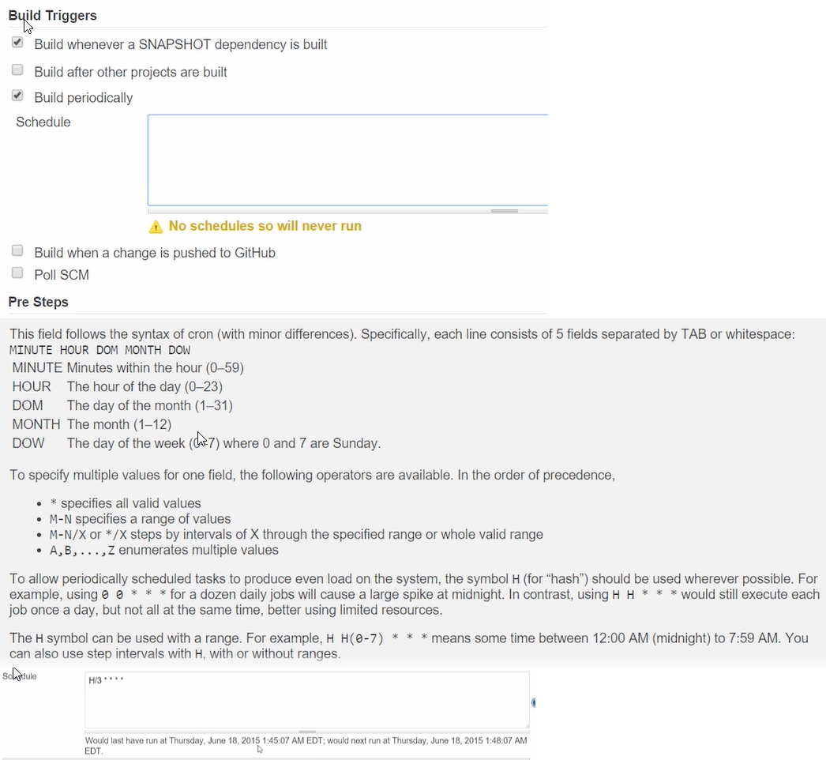

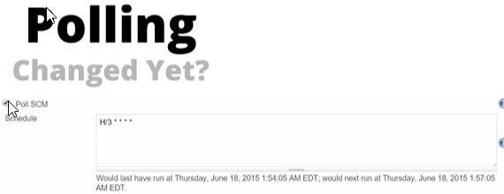Configure Job to run every 3 minutes.

If we select the Poll SCM option, Jenkins would check for change in source control system and then only trigger the build.

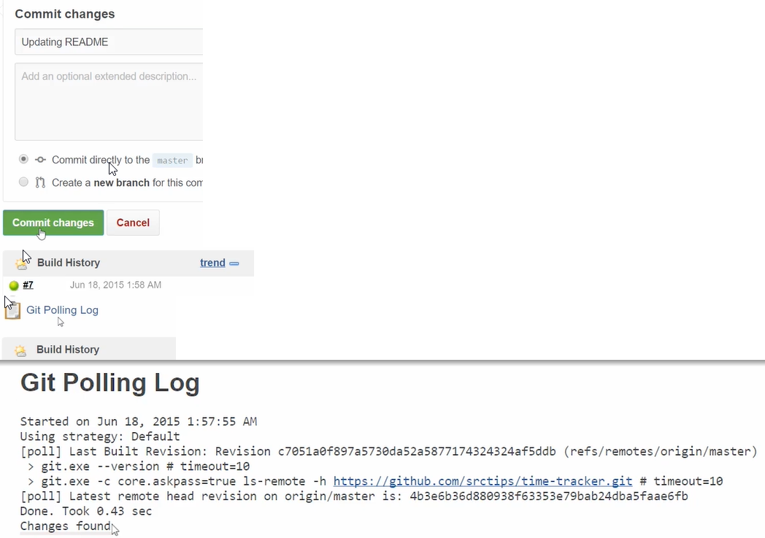

We see, that it detected the change, and added a new tab and built automatically.

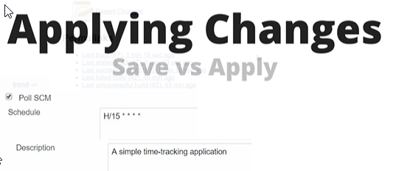

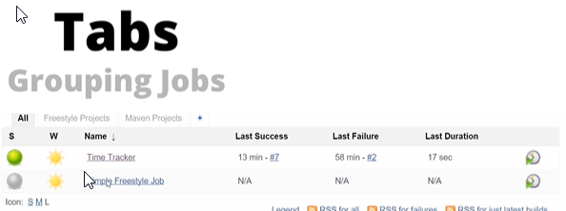

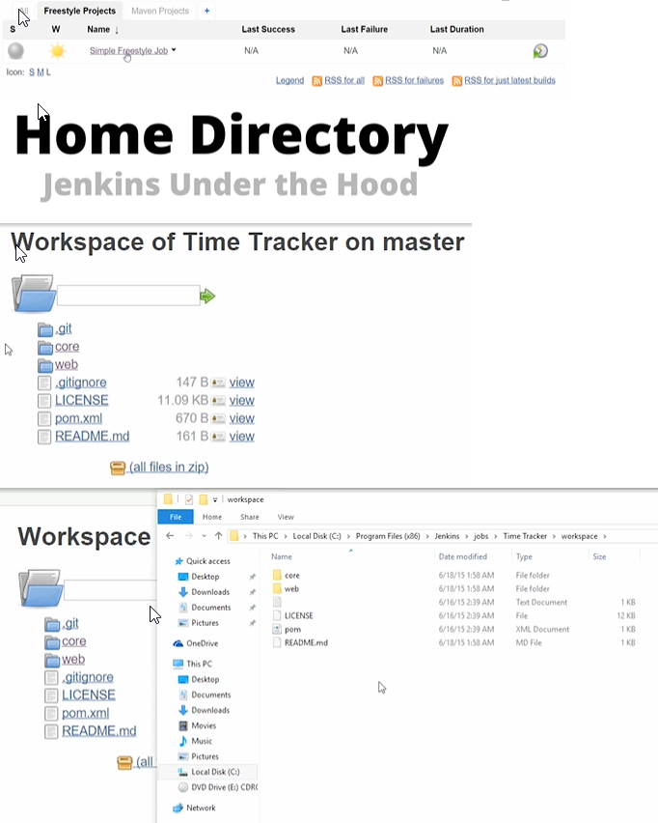

Workspace file structure matches with that of Jenkins.

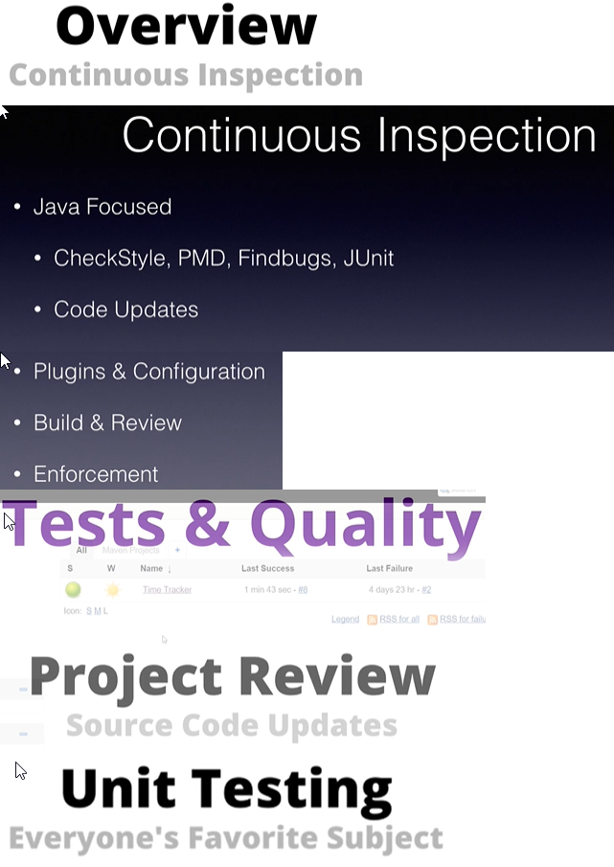

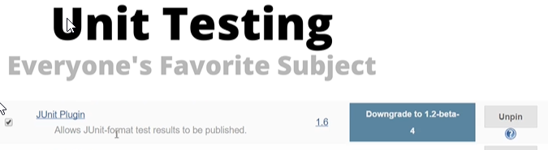Time tracker application code modified to include coverage for Junit.

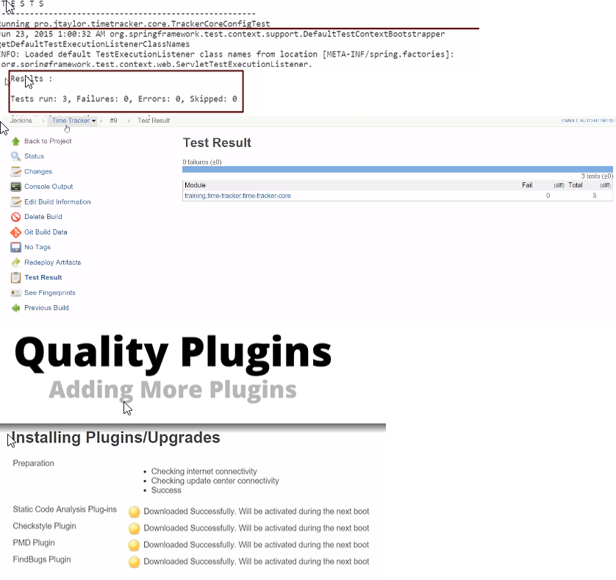We ensure that the Junit plugin is already installed.

Install the checkstyle, PMD and FindBugs Plugins.

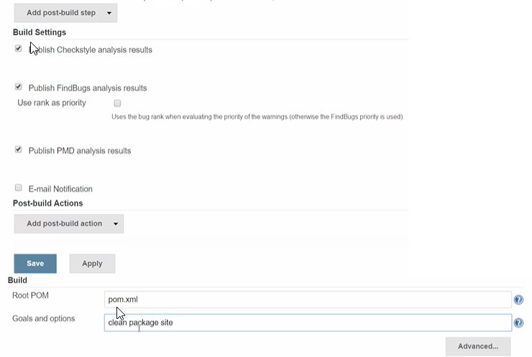

Clean, package and site are all phases within different life cycles. Clean runs the clean life cycle, package runs the default life cycle upto the package phase, and site runs the site life cycle.

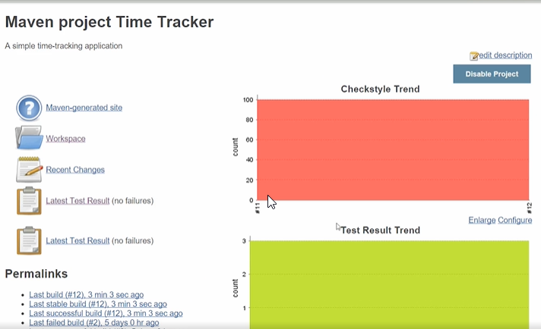

Check the trends.

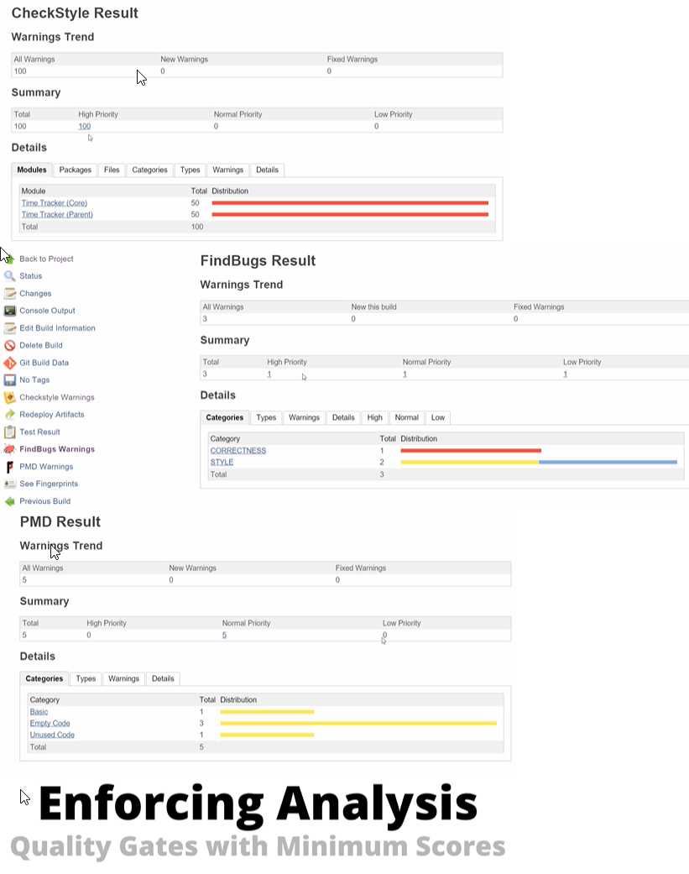

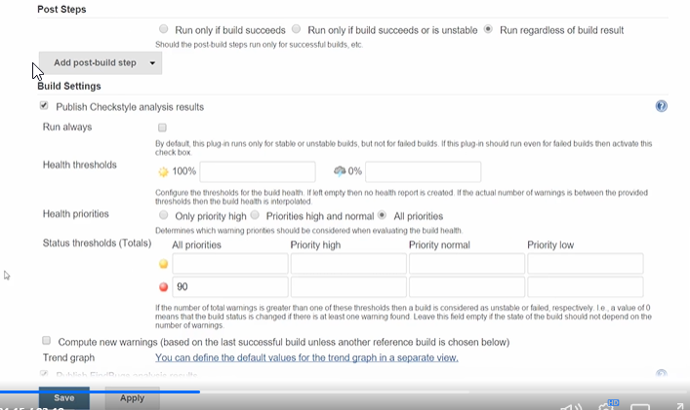

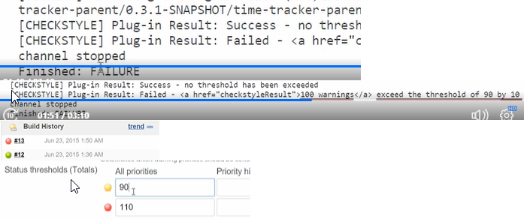Set checkstyle, if have more than 90 issues we want to fail the build.

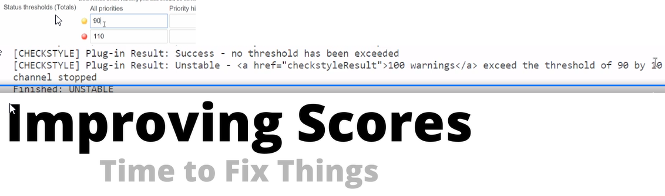If more than 90, give a warning but failed if more than 110.

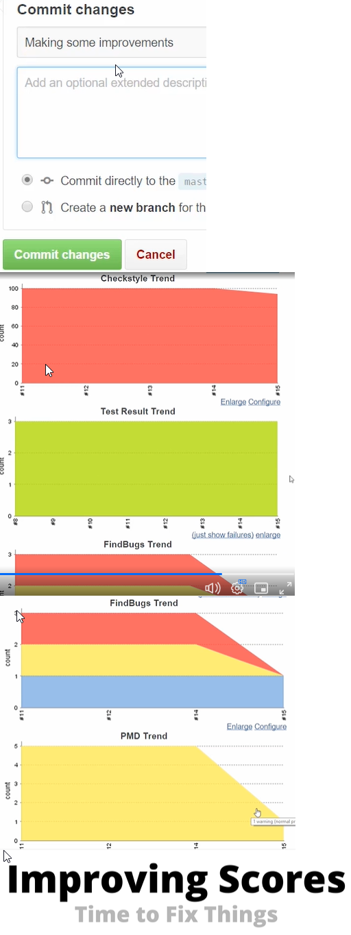

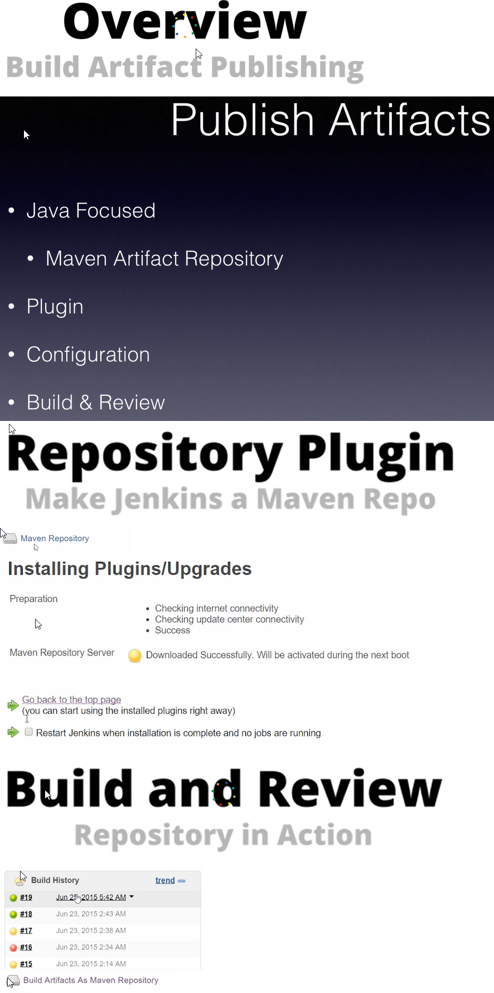

In the build artifacts as maven repository tab, we find the upstream url. Because of the maven repository server plugin.

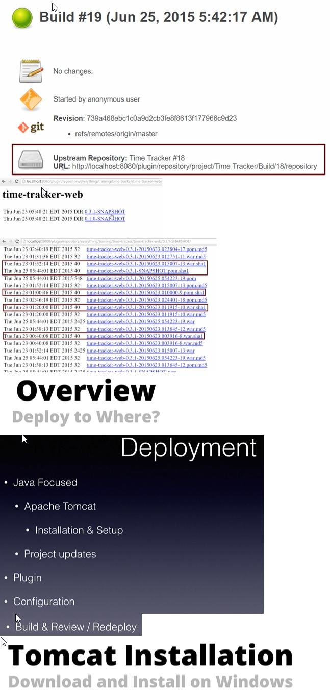We see if the build artifacts have been published in the latest build.

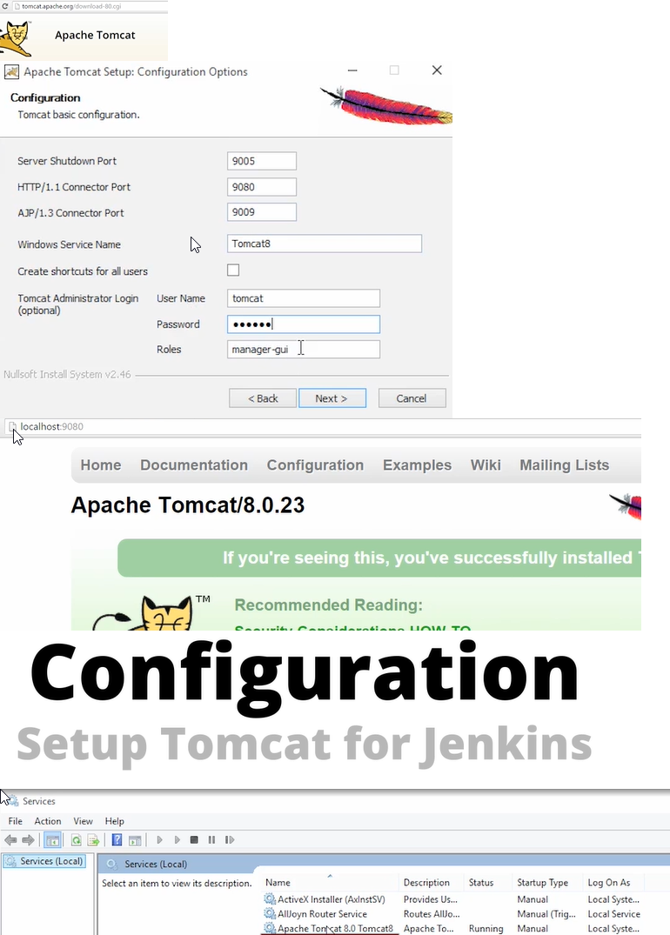

Apache tomcat service must be available.

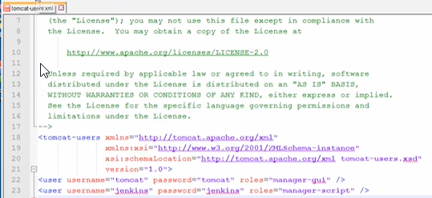

In tomcat users.xml in folder structure, add the Jenkins username and role.

Right click tomcat in services and select start.

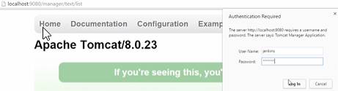

Go to the above url, and type the just edited username and password.

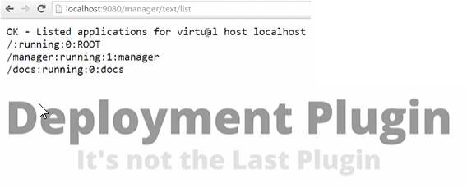

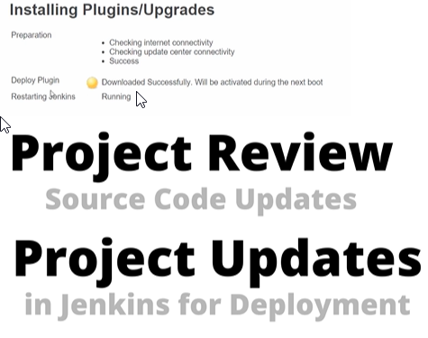Now after configuring tomcat, integrate it with Jenkins.

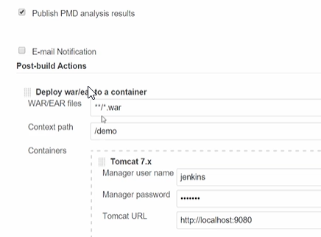

We type the name on WAR file, to select any WAR file available in the project.

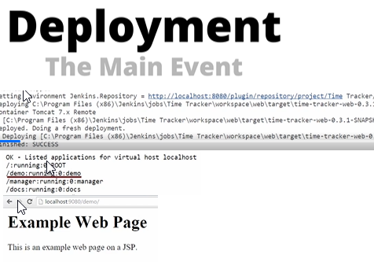We type the manager script username and password we saved earlier.

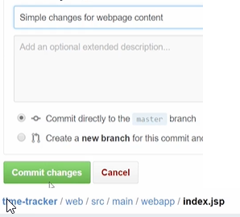Now we confirm our deployment from Jenkins.

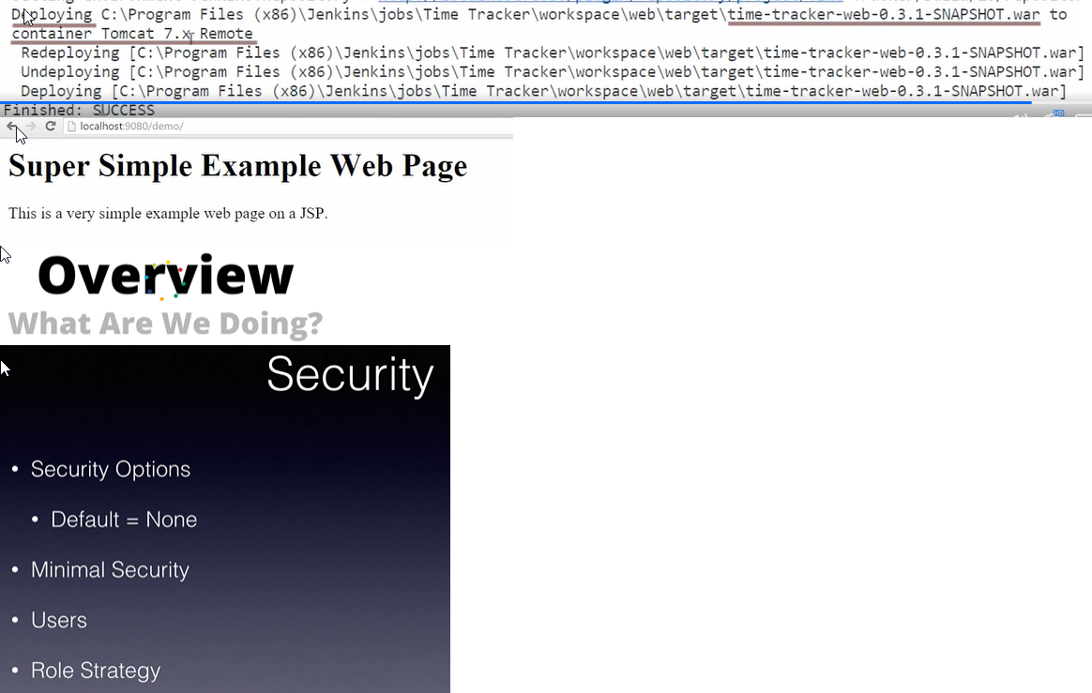

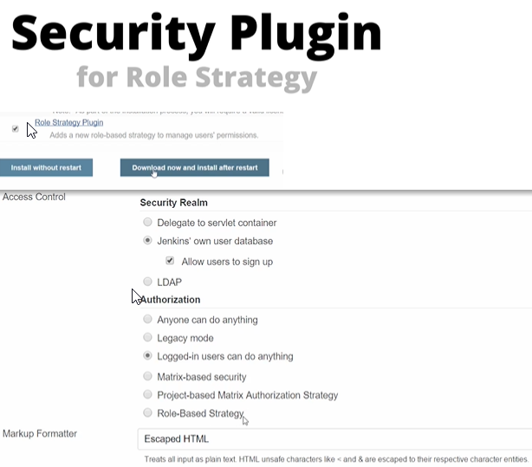Security: We can set login using username and password, and if set access to build and few features will enable only while doing so.

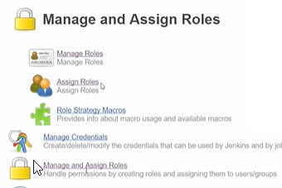Under authorization we should now have an option for role based strategy.

Now we have manage and assign roles, in manage Jenkins page.

